**1/ Admin:**

**a/ Manage client account**



* Admin can add new client to db: which field client currently working in,contact info
* Admin can edit client info
* Assign client to view the task(Optional): For client to catch up team’s working schedule

**b/ Manage team member**



* Admin can manage basic contact info of team member
* Admin can add new team member account
* Admin can set role for member(Dev,PM,Accountant,Designer)

**c/ Manage project**



* Admin can view all project and filter by status and company
* Admin can delete project
* Admin can manage member for that project by add user to the project,add role for user,remove user out of project
* Admin can view in project task

1. Admin can create a task list then admin can add a task and subtask
2. View a task
3. Complete a task for member
4. Assign a task
5. Report
6. Add working rate for each member
7. Comment in specific task
8. Add file in specific task

**2/Member**

**a/ Manage project task**

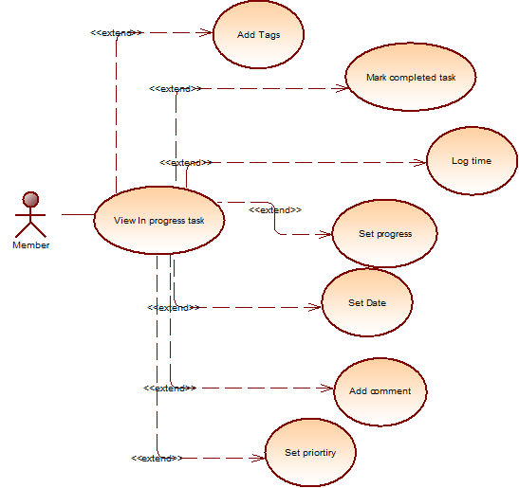

* Member can add a tags for specific task(Bug,Improve etc…)
* Member can mark a task a completed
* Member can log time for specific task
* Member can set percent of complete for that task
* Member set eta date for the task
* Member can comment in a task if they have nay question
* Member can set priority for the task

**b/ Manage account info**

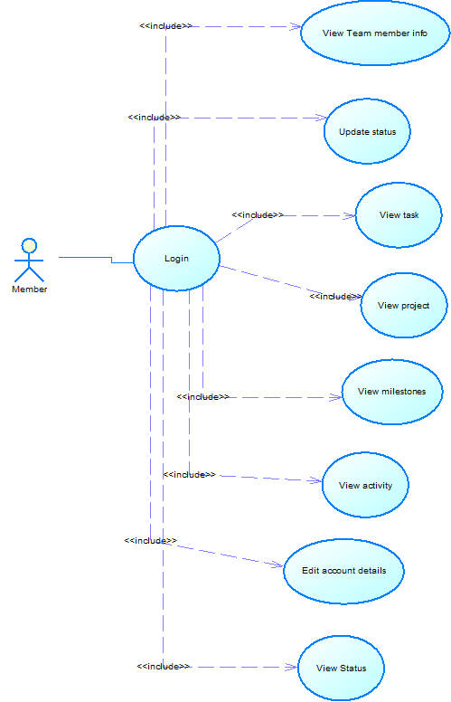

* Member after login they can view other team member info
* Member can update they current status
* Member can view all task
* Member can view project
* Member can view milestone
* Member can view all activity of team
* Member can edit their account info
* Member can view other team member’s status

**3/ Accountant**



* Accountant will manage the working rate for each team member(how much they earn in 1h)
* Accountant can import invoice
* Accountant can export billing for each task,each project
* Accountant can summarise company income(month,year)